GRAPHICS DESIGN

WITH

ADOBE PHOTOSHOP

TRAINING NOTES
Table of Contents
Introduction to Photoshop and bitmap graphics 5
About bitmap graphics and vector graphics 5
Image size and resolution 5
Colour depth 5
The Photoshop interface 6
Options bar 6
Toolbox 6
To select a tool, click on its icon in the Toolbox. Some tools have additional, hidden tools which can be selected by holding down the left mouse button and then clicking the required tool. The presence of hidden tools is indicated by a small black triangle in the bottom right-hand corner of the tool icon. For a description of each tool, see Online Help. 6
Canvas 6
Floating palettes 6
Status bar 6
To zoom in or out 7
Basic operations 7
To launch the program 7
To open an existing document 7
To create a new document 7
To undo changes to an image 8
To save a file 8
Getting help 8
To exit Photoshop 8
Choose File > Exit. 8
To crop an image 8
To rotate an image 8
To resize the canvas 8
Selecting 9
To select the entire image 9
To remove a selection 9
Using the basic selection tools 9
Rectangular Marquee tool 9
Lasso tool 9
Magic Wand tool 10
To move a selection 10
To duplicate a selection 10
To invert a selection 10
Making colour and tonal adjustments 11
To adjust brightness and contrast 11
Using the Hue/Saturation command 11
Using the Color Balance command 11
Using the Levels command 12
To invert an image 12
To remove all colour from an image 13
Using the painting tools 13
About foreground and background colours 13
Setting the foreground colour 13
Setting the background colour 14
Using the Brush/Pencil tools 14
To fill a selection or layer 15
Using the Paint Bucket tool 15
Using the Gradient tool 15
Creating custom gradients 16
Working with layers 17
Layer basics 17
To create a new layer 17
To delete a layer 17
To rename a layer 17
To move a layer 18
Locking a layer and its properties 18
To edit or paint on a layer 18
To link layers 18
To change the opacity of a layer 19
Flattening an image 19
To apply a style 20
To edit a style 20
To edit a style 21
To temporarily disable a style 21
To remove a style 21
Using layer preset styles 21
To apply a preset style 21
To create a preset style from a custom style 21
Using adjustment layers 23
To add an adjustment layer 23
To edit an adjustment layer 23
To temporarily disable an adjustment layer 23
To delete an adjustment layer 23
Working with type 25
To add type to an image 25
Editing type 25
Type layers and layer styles 25
Rasterizing type layers 25
Committing changes to a type layer 25
Drawing vector shapes 26
To draw a shape 26
To change the fill colour of a shape 26
To transform shapes 26
Transforming 27
Specify what to transform 27
Perform the transformation 27
Working with masks 28
Using a mask to modify a selection 28
1. Make a selection 28
2. Switch to Quick Mask mode 28
3. Edit the mask with the painting tools 29
4. Convert the mask back into a selection 29
Saving selections as masks 29
About channels 29
To save a selection to an alpha channel 30
To load a selection from an alpha channel 30
Editing masks 30
An example 30
Layer masks 31
To add a layer mask 31
To edit a layer mask 31
To disable a layer mask 31
To enable a layer mask 31
To delete a layer mask 32
Using filters 32
Adding a filter 32
Saving images to other file formats 32
To export an image to another format 33
To optimise an image for Web publication 33
Printing from Photoshop 34
Reducing the file size of an image 34
Setting up a print job 34
Learning resources 35
Photoshop Online Help 35
Web resources – www.adobe.com/photoshop 35
Adobe Photoshop Classroom in a Book – Adobe Press 35
Some useful keyboard shortcuts 35
Glossary 36

Introduction to Photoshop and bitmap graphics
Adobe Photoshop 7 is an advanced photo retouching, image editing and colour painting application which has become an industry-standard graphics production tool.

About bitmap graphics and vector graphics
Photoshop and other image editing programs such as Paint Shop Pro and Corel Paint are used for generating and editing bitmap (or raster) images. Bitmap images are composed of an array of pixels (short for picture elements). A pixel is the smallest editable element of a bitmap image and each one is assigned a specific location within the array and a colour value. When working with bitmap images you edit pixels – adding them, deleting them or changing their colour or transparency in some way. Bitmap images are resolution-dependent, which means that they contain a fixed number of pixels to represent the image data. As a result, the quality of a bitmap image can degrade and appear jagged if magnified or scaled up too far. This contrasts with vector graphics packages such as FreeHand and Illustrator where the user works with vectors – mathematically-defined lines and curves that can be moved and resized without any loss of quality. Bitmap images are ideal for representing continuous tone images such as photographs and paintings where subtle gradations of colour and tone need to be rendered. Vector graphics, on the other hand, are the preferred choice for representing objects that may need to be scaled to different sizes - for example, type, logos, diagrams and plans.

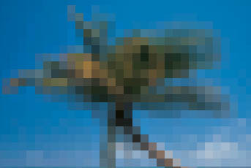
Close-up showing individual pixels

Image size and resolution
Image resolution refers to the number of pixels displayed per unit of printed length in an image, usually measured in pixels per inch (ppi). The amount of detail in an image depends on its pixel dimensions. When printed, an image with a high resolution contains more, and therefore smaller, pixels than an image with a low resolution. For example, an image measuring 1 x 1 inch with a resolution of 72 ppi contains a total of 5184 pixels (72 pixels wide x 72 pixels high = 5184). The same 1 x 1 inch image with a resolution of 300 ppi contains a total of 90,000 pixels (300 pixels wide x 300 pixels high = 90000). The higher the resolution, the larger the file size.

Colour depth
Also known as bit depth, colour depth is a measurement of how much colour information is stored with each pixel in the image. The higher the bit depth, the more colours are available to display the image. This means more accurate colour representation. A pixel with a colour depth of just 1 (2¹) has two possible values – black and white. A pixel with a colour depth of 8 has 256 (2⁸) possible values.This is known as 8-bit colour. A pixel with a colour depth of 24 has around 16 million (2²⁴) possible values. This is known as 24-bit colour.

The Photoshop interface
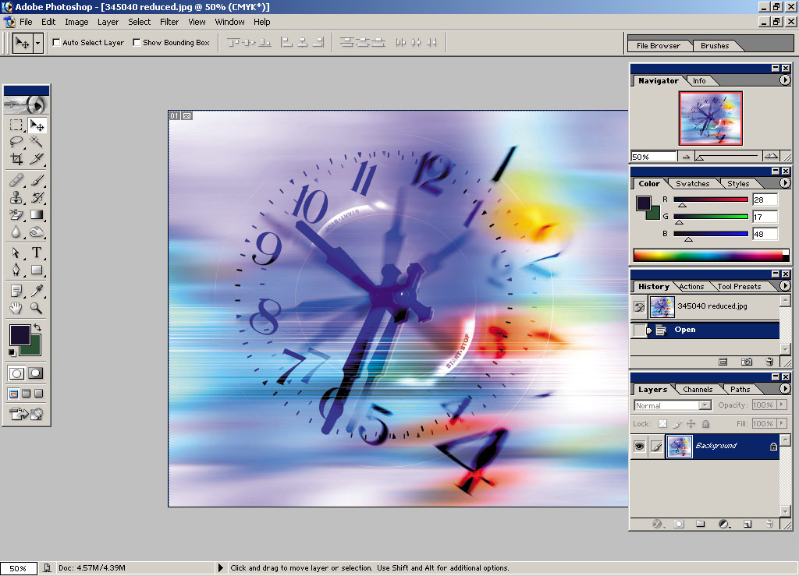
Toolbox
Canvas
Floating palettes
Options
bar
Status bar

Options bar
Allows options to be set for individual tools – changes as different tools are selected.
To show or hide, click Options on the Window menu.

Toolbox

To select a tool, click on its icon in the Toolbox. Some tools have additional, hidden tools which can be selected by holding down the left mouse button and then clicking the required tool. The presence of hidden tools is indicated by a small black triangle in the bottom right-hand corner of the tool icon. For a description of each tool, see Online Help.

Canvas
This is the area where you work on your images.

Floating palettes

When Photoshop is first launched, the floating palettes appear stacked in default groups. To bring a palette to the front of its group, click its name tab. To show or hide a palette, click the palette name on the Window menu (visible palettes have a tick next to their name). A palette can be expanded or contracted by double-clicking its name tab.
To hide or display all open palettes and the toolbox with a single keystroke, press Tab. To hide or display palettes only, press Shift+Tab.

Status bar
Provides useful information such as the current level of magnification, the file size of the active image and short instructions for the currently selected tool. Show or hide by selecting Status Bar on the Window menu.

To zoom in or out
- Select the Zoom tool .
- Click over the image to zoom in. Hold down the <Alt> key whilst clicking to zoom out.

Basic operations

To launch the program
- Click the Start button and select Programs, Graphics and CAD, Photoshop 7.

To open an existing document
- From the File menu, choose Open. Alternatively, open the File Browser by clicking on its tab at the top right of the application window. The File Browser provides an interface similar to that of Windows Explorer, enabling you to browse the hard drive and view thumbnails of your images.
- Navigate to where the file is located, select it and then click Open.
The Open Recent command on the File menu enables you to quickly open the most recently accessed documents.

To create a new document
- From the File menu, choose New. The New Document dialog box appears.
- If you wish, type a name for the document in the Name field.
- Enter a height and width for the image and a resolution value. The resolution you choose depends on how the image will be used. For online images, choose 72 ppi. If you will be printing your image to the Brookes central printers, choose a value between 100 and 200 ppi (150 ppi gives good results in most cases). Images destined for commercial printing should have a resolution of 300 ppi.
- Choose an appropriate mode:
Bitmap – for 1-bit images that use one of two colour values (black or white) to represent the pixels in an image.
Grayscale – for images that consist of 256 shades of grey – use for monochrome images.
RGB Color – the default mode for new Photoshop images and the colour model used by computer displays and data projectors. Use for images that are to be viewed online.
CMYK Color – use when preparing images to be printed using process colours.
Lab Color – a specialised mode that you will not normally need to use. Lab is the internal reference colour model used by Photoshop to perform conversions from one mode to another.
Note: it is recommended that you work on colour images in RGB mode as all the Photoshop painting and editing tools are available in this mode. You can change the mode of an image at any time by choosing the Mode command from the Image menu.
- For Contents, select an option:
White – to fill the background with white.
Background Color – to fill the image with the current background colour.
Transparent – to create an image with a transparent background.
Note: transparency is indicated in Photoshop by a grey and white checkerboard pattern. This pattern does not print or display when imported into other applications.
- Click OK.

To undo changes to an image
From the Edit menu, select Undo xxxx (where xxxx = the last operation performed).
Use the History palette (to display, select History from the Window menu) to jump to any recent state during the current working session. By default, the palette lists the twenty most recent states; older states are automatically deleted.
To return to the last saved version of the image, select Revert from the File menu.

To save a file
From the File menu, choose Save As. Enter a name and location for the new document, then click Save. By default, documents are saved in the native Adobe Photoshop (.PSD) format.

Getting help
From the Help menu, choose Photoshop Help or press <F1>.
If you cannot find the answer in Online Help or you have a technical query, contact the Graphics Workshop on extension 4474.

To exit Photoshop

Choose File > Exit.

To crop an image
- Select the Crop tool .
- Drag a bounding box to enclose the area you wish to retain. The area to be cropped is dimmed.
- If necessary, adjust the crop by clicking and dragging handles on the bounding box.
- Click OK to perform the crop.

To rotate an image
- From the Image menu, select Rotate Canvas and choose a preset angle or flip option from the sub-menu. Selecting Arbitrary lets you specify a custom angle of rotation.

To resize the canvas
Resizing the canvas lets you add or remove workspace around an image. For example, you will need to increase the canvas size if you paste in a selection that is larger than the current image workspace.
- From the Image menu, choose Canvas Size.
- Enter the new dimensions in the Width and Height fields.
- For Anchor, click a square to determine where on the new canvas the image will be positioned.
- Click OK.

Selecting
It is essential to know how to select the areas of an image that you wish to edit. You must select part of an image before making any changes to that part. In most cases, once you have made a selection, only that area of the image will be affected by any changes you make. Selections can be copied and pasted between different images. Photoshop provides a wide range of selection tools, the most important of which are described below. For information on selection tools not covered here, consult the Online Help.

To select the entire image
From the Select menu, choose All. Keyboard shortcut: <Ctrl/A>.

To remove a selection
From the Select menu, choose Deselect. Keyboard shortcut: <Ctrl/D>.

Using the basic selection tools
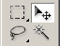
Rectangular marquee tool
Lasso tool
Move tool
Magic Wand tool

Rectangular Marquee tool
Use to make rectangular selections within the image. To use:
- Select the tool from the Toolbox.
- Click and drag to create a marquee. An animated dashed rectangle (sometimes referred to as ‘marching ants’) encloses the selected area.
To constrain the selection area to be a square, hold down the Shift key as you drag. Hidden under this tool are additional tools for making elliptical, single row and single column selections.

Lasso tool
This tool makes a freehand selection around the area you wish to edit. To use:
- Select the tool from the Toolbox.
- Click and drag in the image to create a selection marquee.
Hidden under this tool is the Polygon Lasso tool, which allows you to make straight line selections around an area, and the Magnetic Lasso tool, which snaps the selection border to clearly defines edges in the image.

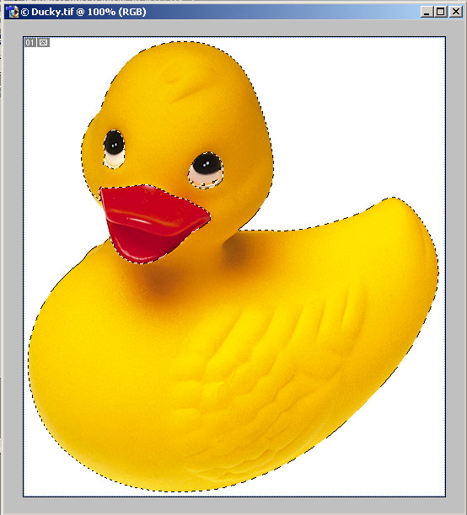
Magic Wand tool
This tool lets you make selections based on the similarity in colour of adjacent pixels. This avoids having to trace the outline of the area. For example, in the picture opposite, all the yellow pixels have been selected using the Magic Wand tool so that the entire duck is surrounded by a selection marquee. To use the magic Wand tool:
- Select the tool from the Toolbox.
- Enter a Tolerance value in the Options bar. Tolerance sets the range of colours to be included in the selection. A low value selects pixels that are very similar in colour to the pixel you first click. A high value selects a wider range of colours.
- In the Options bar, check Contiguous to select only adjacent pixels. Deselect Contiguous to select pixels of a similar colour wherever they are in the image – for example, clicking one of the duck’s eyes will select the black pixels in both eyes.
- Click the area you wish to select. To add to an existing selection, hold down the Shift key and click in the image. To subtract from the selection, hold down the Alt key and click in the image.
If you don’t select the entire area with the first mouse click, either remove the selection, increase the tolerance value and try again, or add to the existing selection by shift-clicking with the Magic Wand tool.

To move a selection
- Select the Move tool.
- Click and drag the selection to a new location.

To duplicate a selection
- Select the Move tool.
- Hold down the <Alt> key whilst dragging a copy of the selection to a new location.

To invert a selection
Having made a selection, choose Inverse from the Select menu. This selects all the unselected parts of an image.
This is useful for selecting an object placed against a solid-coloured background. For example, to select the duck in the image above, first select the white background with the Magic Wand tool and then invert the selection. The duck is now selected and can be copied and pasted onto a different background.

Making colour and tonal adjustments
Photoshop provides a variety of colour correction tools, ranging from basic adjustments such as Brightness/Contrast to more sophisticated controls such as Levels and Curves. All the tools work in essentially the same way by mapping the current values of pixels to new values specified by the user. The following covers the most frequently used tools.
For details of others, refer to the Online Help.

To adjust brightness and contrast
- From the Image menu, select Adjustments then Brightness/Contrast.
- Adjust by dragging the sliders - dragging to the left decreases the level and dragging to the right increases it. Check Preview to see the changes in the image without exiting the dialog box.
- Click OK.

Using the Hue/Saturation command
This command enables you to adjust the hue, saturation and lightness of the individual colour components - or all the colour components - of an image. Hue is the actual colour reflected from or transmitted through an object. Saturation is the strength or purity of a colour. Lightness refers to the relative lightness or darkness of a colour.
- From the Image menu, choose Adjustments then Hue/Saturation.
- From the drop-down list at the top of the dialog box, choose which colour to adjust. Choosing Master from the list allows you to adjust all the colours in the image simultaneously.
- Drag the sliders as required. Check Preview to see the changes in the image without exiting the dialog box.
- Click OK.
To create a tinted/duotone effect (i.e. to reduce a full-colour image to just one hue), check Colorize then adjust the sliders. This feature can be used to simulate the sepia tone often found in old photos.

Using the Color Balance command
Use this command to change the mixture of colours in an image.
- From the Image menu, choose Adjustments then Color Balance.
- Select Shadows, Midtones or Highlights to specify which area of the image’s tonal range you want to adjust.
- Drag a slider towards the colour you want to increase; drag away from the colour you want to decrease. Check Preview to see the changes in the image without exiting the dialog box.
- Click OK.

Using the Levels command
This command is very useful for increasing the contrast and tonal range of images that look ‘flat’ and washed out. Unlike the Brightness/Contrast command, which affects all the pixels in the image, the Levels command offers more control in that you can make changes to just the shadows, midtones or highlights, or a combination of these.
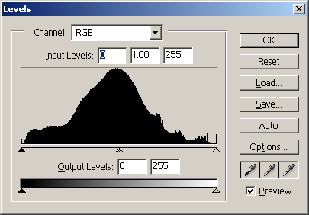
Shadows
Midtones
Highlights
Histogram

- From the Image menu, choose Adjustments then Levels. Keyboard shortcut: <Ctrl/L>.
- The Levels dialog box contains a histogram, which shows the number of pixels present at each brightness level in the image – from 0 (black) at the far left to 255 (white) at the far right. Check Preview to see the changes you make reflected in the image without exiting the dialog box.
- To lighten the image and increase the contrast in the highlight areas, drag the white highlights triangle to the left.
- To darken the image and increase the contrast in the shadow areas, drag the black shadows triangle to the right.
- To adjust the contrast in the midtones, without substantially affecting the highlights and shadows, drag the middle grey triangle.
- Click OK.

When using any of the image adjustment commands, you can reset the image back to its original state without closing the dialog box by holding down the Alt key and clicking the Reset button.

To invert an image
From the Image menu, choose Adjustments then Invert. Keyboard shortcut: <Ctrl/I>. This creates a negative image.

To remove all colour from an image
From the Image menu, choose Adjustments then Desaturate. Keyboard shortcut: <Shift/Ctrl/U>. This gives the image a greyscale appearance.

Using the painting tools
Photoshop’s painting tools and fill commands allow the user to add pixels to an image, either to create original artwork or to retouch existing artwork. There is also a selection of erasing tools for removing pixels from an image.

About foreground and background colours
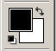
Foreground colour swatch
Background colour swatch
Default colours
Switch colours

Foreground/background colour swatches at bottom of Toolbox

Foreground colour: this is used by Photoshop to paint and to fill selections and as the start colour for gradient fills. By default it is black.
Background colour: this is used as the end colour for gradient fills and to fill in the erased parts of an image (if you are working on the background layer or transparency is locked). The background colour can be thought of as the canvas behind the painting – when you erase the paint, the canvas colour behind it is revealed. By default it is white.

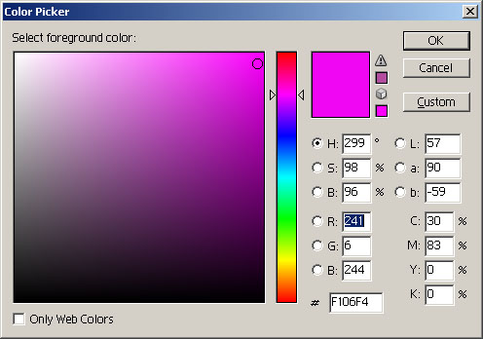
The Color Picker

Setting the foreground colour
Before painting or filling you need to set a foreground colour. This can be done in any of the following ways:
- Click the Foreground colour swatch at the bottom of the Toolbox to open the Colour Picker. Pick a colour using the colour field and slider, or enter numeric values for one of the four colour modes (HSB, RGB, Lab or CMYK) and then click OK. The Foreground colour swatch changes to the colour you just selected.
- Open the Swatches palette: from the Window menu, choose Swatches. Select a colour from the palette. The Foreground colour swatch changes to the colour you selected.
- Open the Color palette: from the Window menu, choose Color. Pick a colour from the spectrum ramp at the bottom of the palette, then refine it using the component sliders.
- Select the Eyedropper tool and sample a colour from the image by clicking it. The Foreground colour swatch changes to the colour you sampled.
Once you have selected a foreground colour, you can start painting or filling with it.

Setting the background colour
Do any of the following:
- Click the Background colour swatch at the bottom of the Toolbox to open the Colour Picker then follow the procedure given above in Setting the foreground colour.
- Open the Color palette. Pick a colour from the spectrum ramp at the bottom of the palette by Alt-clicking it, then refine the colour using the component sliders.
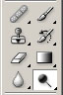
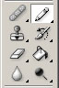
- Select the Eyedropper tool and sample a colour from the image by Alt-clicking in the image.
Brush
Clone stamp
Eraser
Gradient fill
Pencil
Paint bucket

Using the Brush/Pencil tools
- Specify a foreground colour (see ‘Setting the foreground colour’ above).
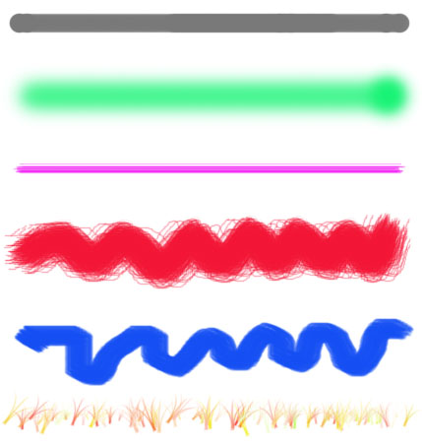
- Select the Brush or Pencil tool. The Brush tool creates soft strokes of colour.
The Pencil tool is used to create hard-edged freehand lines.
- In the Options bar, choose a preset brush from the list and specify the diameter in pixels for the brush, using the slider control or by entering a value. Photoshop provides a large selection of brush styles (see samples opposite), which enable you to paint with different patterns and textures.
Different brush styles
Use the square bracket keys on the keyboard to increase (<]>) or decrease (<[>) the brush diameter to the next size up or down.
- In the Options bar, specify an opacity for the brush or pencil strokes.
- For the Brush tool, specify the flow – that is, how quickly the paint is applied. To create an airbrush effect, click the Airbrush button in the Options bar.

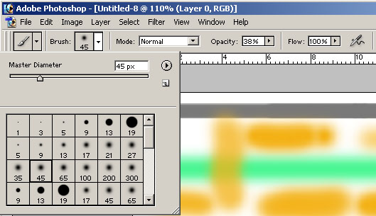
Brush presets
Brush diameter
Options bar
Click to enable airbrush

Brush presets and sizes can be set for nearly all the painting and editing tools, not just the Brush and Pencil tools. These options are available for the following tools: Blur, Burn, Clone stamp, Dodge, Eraser (normal, Background and Magic), Healing, History, Art History, Pattern Stamp, Sharpen, Smudge and Sponge.

To fill a selection or layer
- Specify a foreground colour (see ‘Setting the foreground colour’) or a background colour.
- Make a selection or, if you want to fill a layer, select that layer in the Layers palette.
- From the Edit menu, choose Fill.
- From the pop-up menu in the Contents area of the Fill dialog box, choose a fill colour – Foreground, Background, Pattern, Black, 50% Gray or White. If you choose Pattern, select a pattern from the list.
- Click OK.

Using the Paint Bucket tool
This tool fills areas of an image that are similar in colour to the pixel you first click.
- Choose a foreground colour (see ‘Setting the foreground colour’).
- Select the Paint Bucket tool then specify settings in the Options bar:
- Specify a tolerance for the fill – this determines how similar in colour pixels must be in order to be filled. A low value only fills pixels that are very close in colour to the pixel you click, whereas a high tolerance fills a broader range of pixels.
- To fill only adjacent pixels, check Contiguous. To fill all similarly coloured pixels in the image, wherever they are, uncheck Contiguous.
- Click the area you want to fill. All pixels whose colour falls within the specified tolerance are filled.

Using the Gradient tool
The Gradient tool lets you apply a gradual, smooth transition between two or more colours.
- Select the Gradient tool.
- To use one of the ready-made gradients, click the triangle next to the gradient sample in the Options bar and select the gradient swatch you require.
- Choose the type of gradient by clicking one of the buttons on the Options bar. Choose from linear, radial, angle, reflected and diamond – see screenshot below.
Gradient types with radial gradient selected
- Position the pointer in the image where you want to set the starting point of the gradient, and drag to define the ending point. To constrain the line angle to a multiple of 45°, hold down <Shift> as you drag.

Creating custom gradients
Photoshop allows you to create custom gradients and save them for reuse.
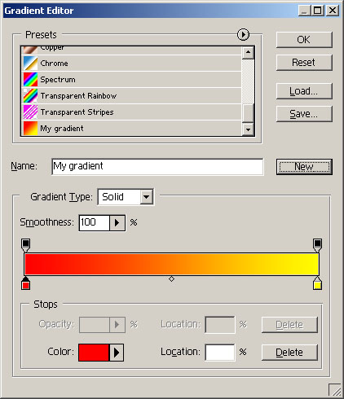
Gradient bar
Start stop
End stop
List of presets
Midpoint
- Select the Gradient tool and click the gradient sample on the Options bar to display the Gradient Editor (see screenshot above).
- Choose a preset from the list on which base the new gradient.
- Define a start colour by double-clicking the start stop at the left end of the gradient bar and choose a colour from the Color Picker. To define an end colour, double-click the end stop at the right end of the gradient bar and choose a colour from the Color Picker.
- To add further stops, for example to create 3-colour, 4-colour or more gradients, click under the gradient bar. To delete a stop, select it then press <Delete>.
- To adjust the midpoint of the gradient, drag the small diamond under the gradient bar to the left or right.
- Type a name for the gradient in the Name field and click the New button. The new gradient is added to the list of presets. Click OK to exit the Gradient Editor.
Custom gradients that you create are stored in the Photoshop Preferences file. This means that they are available each time you launch the program. They will, however, be lost if the Preferences file is deleted or damaged, or if the gradients are reset. To permanently store your gradients, save them to a library. Details of how to do this can be found in the Online Help.

Working with layers
Photoshop allows you to organise artwork onto separate layers. Layers can be thought of as sheets of acetate stacked on top of one another. Areas of a layer that contain no pixels (artwork) are transparent, which means that you can see through to the layers below. Layers are a powerful feature of Photoshop that enables you to work on one element of your artwork independently of the others. For example, if you are working on an image that contains text on one layer and a picture on the other, you can turn off the picture layer in order to focus on editing the text. In addition, any changes you make to the text layer will not affect the picture layer. Layers allow you to change the composition of an image by changing their order. You can change the opacity of one layer so that more or less of the layer(s) below it are visible. Special effects can easily be added by using layer styles. Using adjustment layers, you can experiment with colour and tonal adjustments without making permanent changes to pixel values.

Layer basics
The Layers palette is the primary tool for managing and manipulating layers in Photoshop. Many of the commands are also available from the Layer menu. To display the Layers palette, choose Layers from the Window menu.
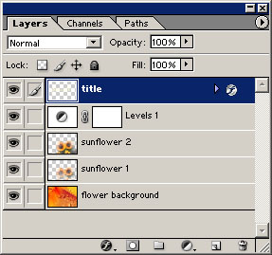
Click to hide or show layer
Selected layer highlighted
Click to adjust
opacity of layer
Adjustment layer
Layer thumbnail
Delete layer
New layer
Blending mode
Layer name
Add layer style
Click to lock/unlock layer

To create a new layer
- Click the New Layer button at the bottom of the Layers palette.

To delete a layer
- Select a layer and click the Delete Layer button at the bottom of the Layers palette.

To rename a layer
- Right-click the layer and choose Layer Properties from the pop-up menu.
- Enter a name and click OK.

To move a layer
- Select a layer in the Layers Palette and drag up or down to a new location.

Locking a layer and its properties
Accidents can happen, so if you are happy with the way a layer looks, lock it to prevent further, unintended changes.
Lock transparent pixels
Lock image pixels
Lock position
Lock all

Lock transparent pixels: click to prevent painting on transparent areas (indicated by a checkerboard pattern) of the image.
Lock position: click to prevent movement or transformation of the layer.
Lock image pixels: click to prevent editing or painting on the layer.
Lock all: click to completely lock the layer.

To edit or paint on a layer
- Make sure the correct layer is selected by clicking on it in the Layers palette. The currently selected layer is highlighted in blue and a small paintbrush icon appears immediately to the left of the layer thumbnail. Note: if a layer is locked, you will need to unlock it before making any changes (see above).
About the background layer
When you create a new layer with a white or coloured background or when you scan an image into Photoshop or open an image from a digital camera or a CD, the bottommost layer is labelled Background in the Layers palette. The background layer cannot be moved up or down or transformed; nor can you change its opacity or blending mode. If you wish to make any of these changes, convert it to a regular layer:
- Double-click it in the Layers palette.
- Give it a new name or accept the default ‘Layer 0’ .
- Click OK.

To link layers
Linking two or more layers together allows you to move their contents together. Linked layers can also be copied, pasted, transformed, aligned and merged.
- Select a layer.
- Click in the column immediately to the left of any layers you wish to link to the selected layer. A link icon appears in the column.
Unlink a layer by clicking on the link icon to remove it.
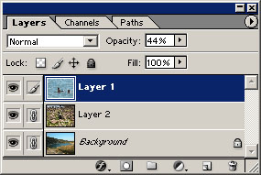
Link icons indicate that layer 2 and the
Background layer are linked to Layer 1

To change the opacity of a layer
- In the Layers palette, drag the opacity slider or enter a value between 0% (= fully transparent) and 100% (= fully opaque). As the opacity is reduced from 100%, the layer(s) underneath start to show through. This creates the interesting effect of two or more images merged into one.

Flattening an image
Flattening is the process of merging several layers into a single layer. Flattening significantly reduces the file size of an image and should always be performed prior to sending an image to print. To flatten an image:
- From the Layer menu, select Flatten Image.
Note: To merge just the linked layers (as opposed to all the layers in the image), choose Merge Linked from the Layer menu.

Once an image has been flattened you will no longer have access to the individual layers from which it was composed. Unless you are absolutely certain that you will not be making any further changes to the image, save a copy of the image and flatten the copy instead. Saving an image in a format that does not support layers (e.g. .JPEG, .BMP) will automatically flatten the image.
Adding custom layer styles
Photoshop’s layer styles (also known as effects) allow you to apply special effects to the contents of a layer. Each style is fully customisable and it is possible to apply multiple styles to a single layer. Layer styles have many uses, for example, you can add drop shadows to pictures and text, create 3-dimensional raised buttons for Web sites or add a colour overlay to the artwork. Custom styles can be saved as presets for reuse.

To apply a style
- In the Layers Palette, select the layer to which you want to apply a style.
- Click the Add a layer style button at the bottom of the palette and choose a style from the pop-up menu. The Layer Style dialog box opens (see screeshot below).
- Specify settings for the style. Check Preview to see the effects of your settings without closing the dialog box. Note: you can apply further styles by clicking the checkboxes next to the style names in the Styles list on the left-hand side of the dialog box. Select a style in the list to view its associated settings and controls.
- Click OK. The style you just applied will appear underneath the layer in the Layers Palette. All styles applied to a layer will be listed in this way. To show or hide the list, click the small triangle.

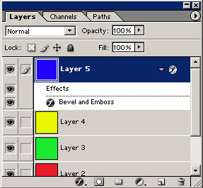
To expand list of applied styles, click triangle
Click to add a layer style
Click to disable style
Layer 5 with Bevel and Emboss style applied
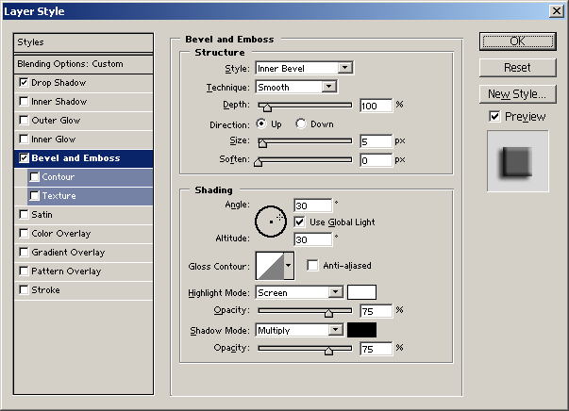

Layer Style dialog box showing settings for the
Bevel and Emboss effect

To edit a style
Once a style has been applied, it can be edited at any time.
- If necessary, expand the style list in the Layers palette.
- Double click the style name to open the Layer Style dialog box.
- Make changes then click OK.

To temporarily disable a style
- Click the eye icon to the left of the style name on the Layers palette.

To remove a style
- Drag the style name over the Trash icon at the bottom of the Layers palette.

Using layer preset styles
Photoshop comes with a large number of preset styles which are organised into libraries according to function. To access these styles, display the Styles palette (from the Window menu, select Styles). Many of the preset styles can be edited in the same way as custom styles – see the previous section.

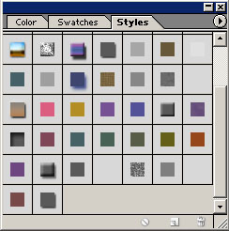
The Styles palette

To apply a preset style
- Select a layer in the Layers palette.
- Select a preset style from the Style palette.

To create a preset style from a custom style
Custom styles that you apply to a layer can be added to the Styles palette so that you can reuse them. Do one of the following:
- To save all the effects applied to a layer as a preset, drag the layer from the Layers palette to the Styles palette, give the style a name and click OK.
- To save just one of the effects applied to a layer as a preset, select an effect from the drop-down list under the layer name in the Layers palette and drag it to the Styles palette. In the New Style dialog box, give the style a name and click OK.

Using adjustment layers
When you make adjustments to an image by choosing a command from the Image>Adjustments sub-menu (see ‘Making colour and tonal adjustments’), the image pixels on the active layer are permanently changed.
Using adjustment layers gives you the freedom to experiment with any of the colour and tonal adjustment tools without permanently changing pixel values. An adjustment layer is associated with a particular adjustment command (e.g. Brightness/Contrast, Levels, Hue/Saturation etc.) and is analogous to a filter through which the underlying layer(s) appear. The power of adjustment layers lies in the fact that colour and tonal adjustments made in this way remain ‘live’, that is, they can be edited at any time or removed altogether.

To add an adjustment layer
- In the Layers palette, select a layer and click the New adjustment layer button.
- Select an adjustment from the drop-down menu.
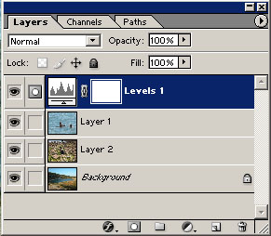
- The dialog box associated with the adjustment you choose opens. Make the adjustments then click OK. A new adjustment layer appears above the layer you selected – all visible layers that lie beneath the adjustment layer will be affected.
Levels adjustment layer
Click here to add
adjustment layer
Adjustment layer
thumbnail

To edit an adjustment layer
- Double-click the adjustment layer thumbnail in the Layers palette. The appropriate dialog box opens.
- Make changes and click OK.

To temporarily disable an adjustment layer
- Click the eye icon to the left of the adjustment layer.

To delete an adjustment layer
- Drag the layer over the Trash button at the bottom of the Layers palette.

Working with type
Photoshop provides sophisticated type facilities which enable you to quickly add text to an image. When adding type to an image, the text appears on its own type layer and can be edited at any time.

To add type to an image
- Select the Type tool .
- Click in the image and type your text. A new type layer appears in the Layers palette.

Editing type
- With the Type tool, select the text.
- Use the controls in the Options bar (see screenshot below) to edit the text.
Font
Style
Point size
Alignment
Font colour

Type layers and layer styles
You can apply layer styles to type layers, for example a drop shadow, by using the procedures detailed earlier in this document. See ‘Adding custom layer styles’.

Rasterizing type layers
Generally speaking, type layers behave in the same way as regular layers with one important exception: in order to use the painting and editing tools, the type layer must first be rasterized. Any attempt to use a painting tool on a non-rasterized type layer will result in an error message being displayed. Similarly, the adjustments sub-menu on the Image menu will be greyed out. Rasterization is the process of converting vector data (type is mathematically-defined vector data) to pixel data. Once a type layer has been rasterized, it can be treated just like any other image layer. Note: rasterized type is no longer editable as text, so make sure that your text is in its finished state before rasterizing. To rasterize type:
- From the Layers menu, choose Rasterize>Type.

Committing changes to a type layer
Clicking in an image with the Type tool puts the tool in editing mode. Any changes you make must be committed using the Commit button on the Options bar, otherwise some commands will be greyed out.

Drawing vector shapes
Photoshop provides a variety of tools for drawing shapes. Shapes appear on their own shape layer and by default are filled with the current foreground colour.

To draw a shape
- Select a shape tool – choose the shape tool currently visible in the Toolbox or one of the hidden tools, as shown in the screenshot below.
- In the Options bar, make sure the Shape layers button is pressed.
- Select a fill colour by clicking the colour swatch at the right end of the Options bar to open the Color Picker.
- Click in the image and drag to create the shape. A new shape layer will appear in the Layers palette
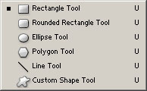
Hidden shape tools

To change the fill colour of a shape
- Select the appropriate shape layer.
- Click the colour swatch at the right end of the Options bar to open the Color Picker.
- Choose a colour and click OK.

To transform shapes
Refer to the next section, ‘Transforming’.

Transforming
Photoshop’s transformation tools allow you to scale, rotate, skew, distort and apply perspective to entire layers, selected parts of layers (see ‘Working with layers’) and shapes (see ‘Drawing vector shapes’).

Specify what to transform
Do one of the following:
- To transform an entire layer, select that layer in the Layers palette
- To transform part of a layer, make a selection on that layer.
- To transform a shape, select the Move tool and the layer containing the shape.

Perform the transformation
- From the Edit menu, choose Transform> Scale, Rotate, Skew, Distort, or Perspective.
- A bounding box appears. Do one or more of the following:
- To scale an object, position the mouse cursor over one of the handles on the bounding box. When the cursor changes to a double-headed arrow, hold down the mouse button and drag. Press the Shift key whilst dragging to maintain the aspect ratio of the shape.
- To rotate an object, position the cursor just outside one of the corner handles and when it changes to a curved double-headed arrow, hold down the mouse button and drag.
- To skew an object, click on one of the side handles and drag to slant the bounding box.
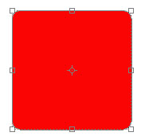
Bounding box
- Press the Commit Transform button on the Options bar. Press <Esc> to cancel the transformation.
For details of the other transformations, refer to the Online Help.
Important: all other Photoshop commands and tools are disabled until you either commit or cancel a transformation command.

Working with masks
Masks in Photoshop are used to protect parts of an image so that they are not affected by any of the editing or painting tools – only pixels in unmasked areas can be modified. Masks are closely related to selections – the unselected area outside a selection marquee is ‘masked’ or protected from editing. Masks can be used in the following ways:
- To modify a selection by converting it to a (quick) mask and using the painting tools.
- To save selections as 8-bit alpha channels so that they can be reused.
- To mask parts of a layer so that the masked areas become transparent, allowing underlying artwork to show through.

Using a mask to modify a selection
By using the Quick Mask facility, it is possible to edit a selection as a mask whilst viewing the image. Regular selections are very limited in terms of the modifications that can be applied to them. When converted to a mask, however, the unselected (i.e. masked) area becomes an 8-bit greyscale image, which means that almost any Photoshop tool or filter can be used to edit it. Having edited the mask, it can then be converted back into a selection and, if required, saved as an alpha channel. An example will make this clear.

1. Make a selection
In this example, the aim is to select just the duck so that it can be copied and pasted onto a different background. First we make a selection using the Magnetic Lasso tool. Using the selection tools, it can be difficult to follow precisely the outline of complex, irregular shapes. In image (1) below, a slip of the mouse has resulted in the selection border also enclosing some of the blue background to the left of the duck’s neck. To correct this using a selection tool we would have to cancel the selection and start all over again. However, by converting the selection to a mask (see image 2) we can easily correct the mistake using one of the painting tools.

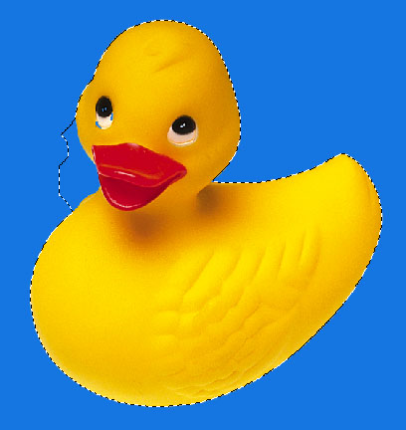
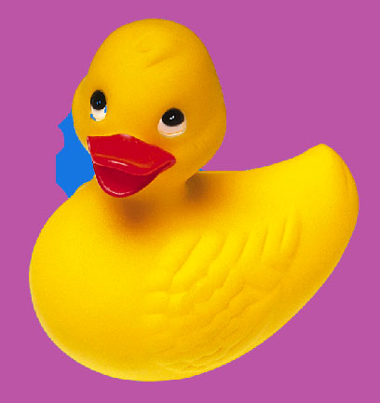
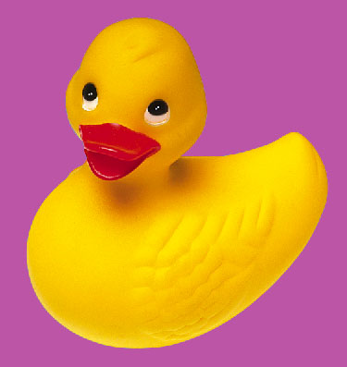
1. Selected area
2. Selected area converted to a mask
3. Mask edited with paintbrush to remove blue background

2. Switch to Quick Mask mode
- Click the Quick Mask button at the bottom of the Toolbox to enter Quick Mask mode. A red overlay appears to mask the area ourside the selection border. This red area is protected from painting and editing.

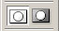
Edit in Standard Mode
Edit in Quick Mask Mode

3. Edit the mask with the painting tools
- Select the Paintbrush tool and choose an appropriate diameter for the brush tip.
- Paint over the remaining blue area. By default, painting with black adds to the mask and reduces the selected area, painting with white removes areas from the mask, extending the selected area. In this example, we need to paint with black over the remains of the blue background to the left of the duck’s neck. As we paint the blue area is covered with the red overlay.

4. Convert the mask back into a selection
- Convert the mask back into a selection by clicking the Edit in Standard Mode button at the bottom of the Toolbox. The red overlay disappears and a new selection marquee that encloses just the duck appears (see image 4, below).
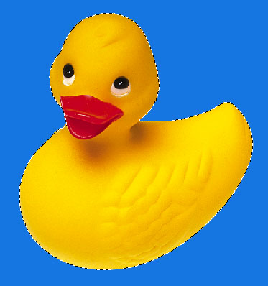
4. Corrected selection

Saving selections as masks
It is often a good idea to save complex, time-consuming selections as masks, which are stored in alpha channels. This allows you to use the masks (and therefore selections) again in the same image or a different image.

About channels
Channels store an image’s colour information. For example, an RGB image will contain three channels, one each for Red, Green and Blue. In addition to colour channels, an image can also contain alpha channels, which are 8-bit greyscale images capable of displaying up to 256 shades of grey. Alpha channels are used to store masks. The Channels palette allows the user to view and manipulate an image’s channels.
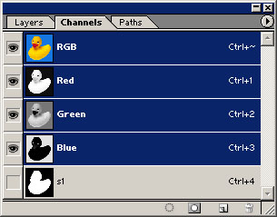
Composite RGB channel
Individual colour channels
Alpha channel storing duck selection as a mask

To save a selection to an alpha channel
- From the Selection menu, choose Save Selection.
- Enter a name for the selection and click OK. A new alpha channel will appear in the Channels palette.

To load a selection from an alpha channel
- From the Selection menu, choose Load Selection.
- Choose a named selection from the drop-down Channel list and click OK. A selection marquee appears in the image.

Editing masks
As stated earlier, masks can be edited using virtually any of the painting and editing tools available in Photoshop. By default, painting with black adds to the mask, decreasing the selected area, whilst painting with white erases the mask, increasing the selected area. Painting with grey creates a semi-transparent mask whose opacity varies according to the level of grey. For example, if you paint with a medium grey, the mask will be 50% opaque (i.e. the pixels will be 50% selected when the mask is loaded as a selection). Painting with a dark grey will result in a more opaque mask (i.e. the pixels will be less than 50% selected when the mask is loaded as a selection). Painting with a light grey results in a more transparent mask (i.e. the pixels will be more than 50% selected when the mask is loaded as a selection).

An example
The image of the duck below shows a noise filter applied to the duck with a varying intensity that gradually increases from 0% at the top to 100% at the bottom. This effect was achieved by adding a black-to-white gradient fill to the mask, loading the mask as a selection and applying a noise filter to the selection. At the top of the duck’s head, the mask is completely opaque, so no noise is applied. At the bottom, the mask is 100% transparent, so noise is added at 100% intensity. In between the two extremes the intensity of the noise gradually increases as the shades of grey get lighter.
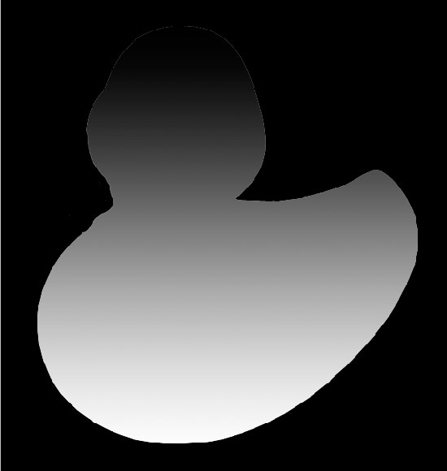
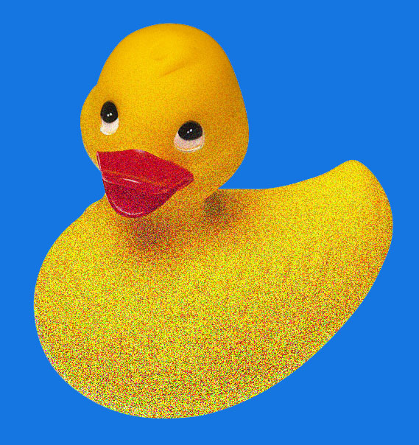
Noise filter applied with increasing strength
Mask with gradient fill applied

To edit a mask
- Select the mask’s alpha channel in the Channels palette. A greyscale image of the mask appears in the document window.
- Use the painting tools and/or filters to edit the mask. Changes are automatically saved to the alpha channel.
- To return to the image, click on the composite RGB channel in the Channels palette. The mask can now be loaded as a selection as described above.

Layer masks
Layer masks control which areas within a layer are hidden and revealed. Masked areas of a layer are transparent, allowing any underlying artwork on other layers to show through. Layer masks can be edited using Photoshop’s painting tools, enabling you to create special effects on a layer without affecting its pixels. Layer masks appear as an icon in the Layers palette – see the screenshot below.
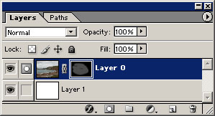
Layer mask icon
Indicates painting
on layer mask

To add a layer mask
- From the Layer menu, select Add Layer Mask. From the menu, choose Reveal All for a mask that reveals the entire layer or Hide All for a mask that hides the entire layer. A mask thumbnail appears in the Layers palette.

To edit a layer mask
- Select the mask by clicking on its thumbnail in the Layers palette – the thumbnail is bordered by double white lines to indicate that the mask is selected.
- Follow the procedure in ‘Editing masks’.

To disable a layer mask
- Right-click on the mask thumbnail in the Layers palette and select Disable Layer Mask from the pop-up menu.

To enable a layer mask
- Right-click on the mask thumbnail in the Layers palette and select Enable Layer Mask from the pop-up menu.

To delete a layer mask
- Right-click on the mask thumbnail in the Layers palette and select Discard Layer Mask from the pop-up menu.

Using filters
Photoshop comes with a large selection of filters, organised into categories, which can be used to add special effects to your artwork. Third party plug-in filters are also available. Once installed, the plug-in filters appear at the bottom of the Filter menu and work in the same way as the built-in filters. Most filters allow you to customize an effect by setting parameters.

Adding a filter
- From the Filter menu, select a filter category and choose a filter from the list. For most filters, a dialog box allowing you to specify settings will open. The screenshot below shows the dialog box for the Gaussian Blur filter.
- Specify settings then click OK. If available, make sure that Preview is checked so that you can see the results of applying the effect before closing the dialog box.
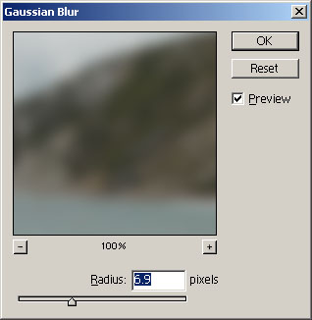
Filters can take a long time to process. When experimenting, save time by applying them first to small, representative selections of your image.

For information on individual filters, refer to the Online Help.

Saving images to other file formats
Photoshop exports to a wide range of image file formats including .TIFF, .JPG, .GIF, .EPS, .BMP and .PDF. Note that the native Photoshop file format (.PSD) is the only one that supports all Photoshop features. The TIFF format will preserve layers and transparency. Saving to other formats will result in the image being flattened – a warning triangle appears in the Save As dialog box to inform you of this. For more information on supported file formats, consult the Online Help.

To export an image to another format
- From the File menu, choose Save As.
- Enter a file name and choose a file format from the Format drop-down menu.
- Click OK. With certain file formats a further format-specific options dialog box will open. For example, the JPEG Options dialog box lets you specify the level of compression.

To optimise an image for Web publication
To optimise your artwork so that it displays correctly in a Web browser, choose Save for Web from the File menu. The Save for Web dialog box allows you to view several optimised versions of the artwork and compare these with the original. For more information, see the Online Help.

Printing from Photoshop
Before printing to the Brookes central printers/plotters, flatten a copy of your image and check the file size – this information can be found on the Status bar. If your image is larger than 25MB, you should reduce the file size.

Reducing the file size of an image
- From the Image menu, select Image Size.
- Making sure Resample Image is checked, lower the resolution by entering a new value in the resolution field. A resolution of between 100 and 150 ppi should suffice. If the image is still too large, try reducing the document size by entering new values in the Height and Width fields. Make sure Constrain Proportions is checked.
- The new file size is displayed at the top of the dialog box.
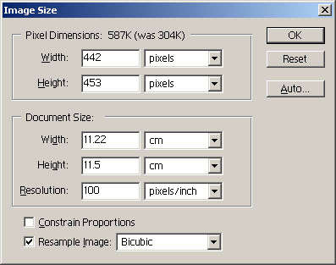
- Click OK

Note: Excessively large images take much longer to print and any image that generates a plot file that exceeds 100MB will automatically be moved to the bottom of the print queue. For more information, refer to the document ‘A guide to printing to the large format printers’, which is available on the Computer Services website.

Setting up a print job
- From the File menu, choose Print with Preview.
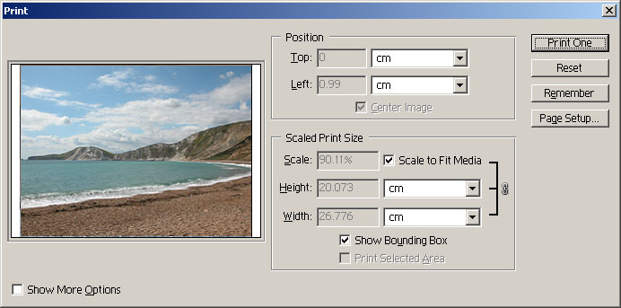
Preview
Check to fit image into printable area
- Click the Page Setup button. Specify a printer and options for that printer.
- Return to the print dialog box (shown above) and check the preview of the image to ensure that all of your image appears within the printable area. If some of the image is being cut off (Photoshop will warn you of this when you try to print), either check Scale to Fit Media or choose a larger paper size.
- Click the Print button, specify the number of copies and click OK.

Learning resources

Photoshop Online Help
Comprehensive information on using all Photoshop commands and features.
From the Help menu, choose Photoshop Help.

Web resources – www.adobe.com/photoshop
Click on “Training and events”. Here you will find links to online tutorials and the Photoshop Expert Center (one-time registration is required), which offers tips, tutorials, help with troubleshooting and free downloads.

Adobe Photoshop Classroom in a Book – Adobe Press
Contains step-by-step lessons covering both the basics and more advanced techniques. Supplied with a CD-ROM of sample files.

Some useful keyboard shortcuts
Key | Command

Menu commands
Ctrl/Z | Undo last action
Ctrl/+ | Zoom in
Ctrl/- | Zoom out
Ctrl/0 | Fit in window
Tab | Hide or show all palettes and toobox
Shift/Tab | Hide or show all palettes
Ctrl/X | Cut
Ctrl/C | Copy
Ctrl/V | Paste
Ctrl/A | Select all
Ctrl/D | Deselect
Alt/Backspace | Fill with current foreground colour
[ | Reduce brush diameter to next size down
] | Increase brush diameter to next size up

Tools
V | Move tool
M | Rectagular Marquee tool
C | Crop tool
T | Type tool
B | Brush tool
Z | Zoom tool
W | Magic Wand tool

Glossary

Alpha Channel | An 8-bit greyscale channel used to store selections as masks.
Bitmap Image | An image composed of a grid of pixels. Bitmap images are resolution-dependent, which means that they can appear jagged if scaled up too far.
Canvas | The workspace area where the image resides.
Channel | Used to store an image’s colour information. An RGB image contains three channels, one each for red, green and blue.
Colour depth | The maximum number of different colours that can be displayed in an image. 24-bit images can contain over 16 million (2²⁴) different colours.
CMYK | Stands for Cyan, Magenta, Yellow, Black. A colour model based on the light-absorbing properties of ink printed on paper. When white light hits a printed ink, part of the spectrum is absorbed and part is reflected back to the eyes. The colour model used for 4-colour process printing.
Greyscale | An image that contains up to 256 shades of grey.
Hue | A colour reflected from or transmitted through an object.
Marquee | A ‘moving’ dashed selection border which appears when using one of the selection tools.
Mask | Used to protect parts of an image so that they cannot be edited, analogous to the area outside a selection marquee. Selections are converted to masks and vice versa.
Pixel | ‘Picture element’ – the smallest addressable element of an image. Each pixel stores colour and brightness information.
Resolution | The number of pixels displayed per unit of printed length in an image, usually measured in pixels per inch (ppi). The higher the resolution, the more detailed the image.
RGB | Stands for Red, Green and Blue. The colour model used for lighting, monitors, scanners and video. Photoshop’s RGB model assigns an intensity value ranging from 0 (black) to 255 (white) for each of the three colour components of an RGB image. When the value of all three components is 255 the result is pure white. All the Photoshop editing facilities are available in RGB mode.
Saturation | The strength or purity of a colour.
Vector Graphics | Images that consist of mathematically-defined objects such as lines, ellipses and rectangles. Whereas bitmap images contain pixel data, vector images consist of a series of drawing instructions. Vector graphics are resolution-independent and retain their sharpness when scaled to any size.

